**Handheld Embedded Smoke Sensor for Pollution Monitoring**

Submitted as partial fulfillment of the requirements for the award of the degree of Bachelor of Technology in Electronics and Communication Engineering

Submitted By

**MANCHAL KUMAR - 6613221001**

**UMMAR C M - 6614M22111**

**M.PRABAKARAN - 6614M22113**

**N.THANGAPANDIYAN - 2113M1622102**

Under the Guidance of

**XXXXXXXXXXXXXX**

Assistant Professor

Department of ECE



**SCHOOL OF ENGINEERING AND TECHNOLOGY**

**DEPARTMENT OF ELECTRONICS AND COMMUNICATION ENGINEERING**

**PONNAIYAH RAMAJAYAM INSTITUTE OF SCIENCE AND TECHNOLOGY (PRIST) DEEMED TO BE UNIVERSITY**

**THANJAVUR – 613 403.**

DECEMBER - 2023



**SCHOOL OF ENGINEERING AND TECHNOLOGY**

**DEPARTMENT OF ELECTRONICS AND COMMUNICATION ENGINEERING**

**PONNAIYAH RAMAJAYAM INSTITUTE OF SCIENCE AND TECHNOLOGY (PRIST) DEEMED TO BE UNIVERSITY**

**THANJAVUR – 613 403.**

**BONAFIDE CERTIFICATE**

This is to certify that the project titled **“Multiprotocol label switching based Virtual Private Network in Internet Service Provider’s at Layer 3”** is a bonafide record of work done by **MANCHAL KUMAR (6613221001), UMMAR C M (6614M22111), M.PRABAKARAN (6614M22113) & N.THANGAPANDIYAN (2113M1622102)** in partial fulfillment of the requirements for the award of the degree of **Bachelor** **of Technology** in **Electronics and Communication Engineering** of **PONNAIYAH RAMAJAYAM INSTITUTE OF SCIENCE AND TECHNOLOGY (PRIST) DEEMED TO BE UNIVERSITY**, Thanjavur.

Internal Guide Head of the Department

Submitted for the University Viva-Voce examination held on ____________

Internal Examiner External Examiner

**ACKNOWLEDGEMENT**

We thank our esteemed and honourable **Chancellor** of **PONNAIYAH RAMAJAYAM INSTITUTE OF SCIENCE AND TECHNOLOGY (PRIST)** Deemed to be University, Thanjavur, for giving this opportunity to work in this project, as part of our B.Tech Course.

We extend our thankful regards to **Vice-Chancellor** **PONNAIYAH RAMAJAYAM INSTITUTE OF SCIENCE AND TECHNOLOGY (PRIST)**Deemed to be University, Thanjavur, for his patronage and granting us an opportunity to work in this project work.

We are greatly thankful to **Registrar PONNAIYAH RAMAJAYAM INSTITUTE OF SCIENCE AND TECHNOLOGY (PRIST)** Deemed to be University, Thanjavur, for his valuable support to complete our project.

We are greatly thankful to **Dean**, School of Engineering & Technology, **PONNAIYAH RAMAJAYAM INSTITUTE OF SCIENCE AND TECHNOLOGY (PRIST)** Deemed to be University, for constantly encouraging us towards the successful completion of our project work.

We are greatly thankful to our beloved **Head of the Department,** Department of Electronics and Communication Engineering & **Project Coordinator**, **PONNAIYAH RAMAJAYAM INSTITUTE OF SCIENCE AND TECHNOLOGY (PRIST)** Deemed to be University, Thanjavur for their help in providing the necessary impetus, facilities, necessary laboratory arrangements and helpful suggestions in completion of the project in all the aspects.

We express our deepest gratitude to **Asst. Prof. _____________**, Internal Guide for guiding us, providing technical help and in considering our project as (his/her) own project, clarifying our doubts, spending (his/her) own precious time in spite of (his/her) busy schedule and helping in the successful implementation of our work.

Finally, we would like to convey our sincere thanks to all the teaching and non-teaching faculties of the Department of Electronics and Communication Engineering, **PONNAIYAH RAMAJAYAM INSTITUTE OF SCIENCE AND TECHNOLOGY (PRIST)** Deemed to be University, Thanjavur.

**Abstract:**

This project focuses on designing and implementing an Air Pollution Detection System using the MQ5 sensor and NodeMCU ESP8266 microcontroller. The system is capable of monitoring air quality and providing an audible alert through a buzzer when pollution levels exceed a predefined threshold.

**Components Used:**

* NodeMCU ESP8266 Microcontroller
* Buzzer
* Power Supply (5V DC)
* Connecting wires and breadboard

**Introduction:**

Air pollution is a significant environmental concern, and this project aims to create a cost-effective and efficient solution for detecting and alerting against elevated pollution levels.

**Methodology:**

* The MQ5 gas sensor is employed to measure air quality by detecting the concentration of pollutants.
* NodeMCU ESP8266 processes the sensor data and determines the pollution level.
* A predefined threshold is set to trigger the buzzer when pollution levels surpass the acceptable limit.

**Circuit Diagram:**

Include a schematic diagram illustrating the connections between the MQ5 sensor, NodeMCU ESP8266, and the buzzer.

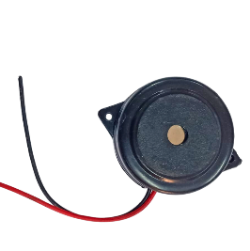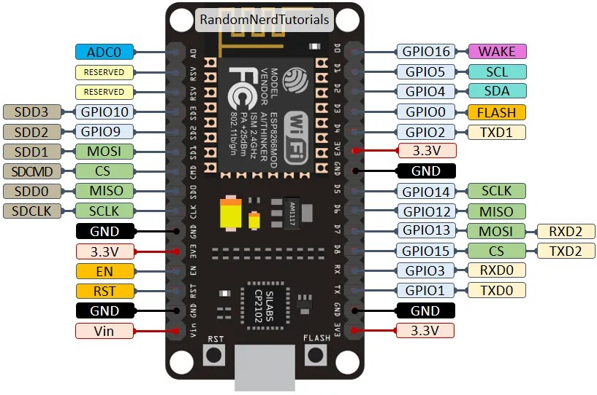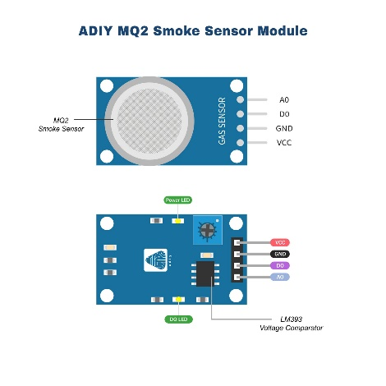

**Implementation:**

* Assemble the components on a breadboard based on the circuit diagram.
* Upload the appropriate code to the NodeMCU ESP8266 using the Arduino IDE.
* Calibrate the MQ5 sensor to ensure accurate pollution level readings.
* Test the system in various environmental conditions to validate its functionality.

**Results:**

The Air Pollution Detection System effectively detects and alerts when pollution levels rise, providing a timely warning to users.

**Conclusion:**

This project showcases a practical and accessible solution for monitoring air pollution using readily available components. The integration of the MQ5 sensor and NodeMCU ESP8266 proves to be a reliable combination for real-time air quality assessment.